Document ID EM/CHECK/03/V2.0 Document Version 02 Document Category Checklist Issue Date 05/2026

Hospital Signage Checklist

Sr. No. | Requirements | Signage Reference | Yes | No
1 | Radiation Hazard | 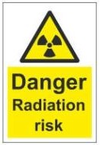
2 | Declaration under PC PNDT Act | 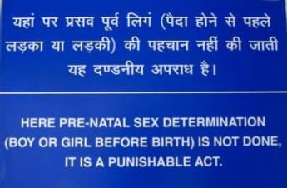
3 | Bio Hazard - including bio medical waste authorized signages | 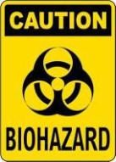
4 | Fire Exit Signage | 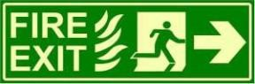
5 | Patient Rights & Responsibility | 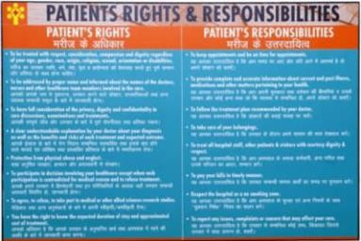

6 | Scope of Services | 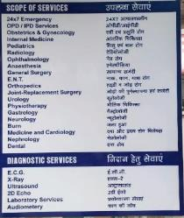
7 | Department Direction | 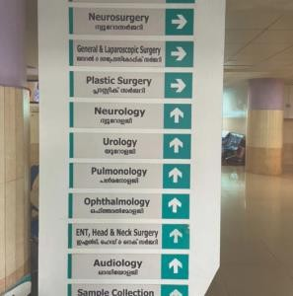
 |  | 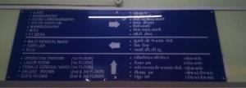
8 | Early Warning Signs | 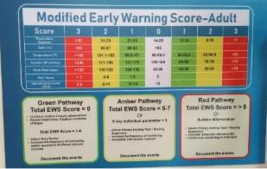

9 | MRI Warning Signage | 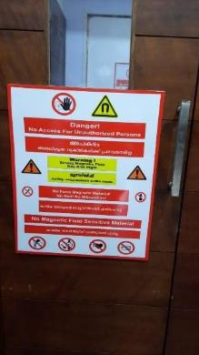
10 | Hazmat | 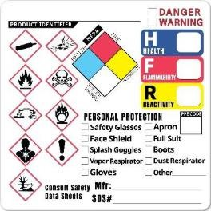
 |  | 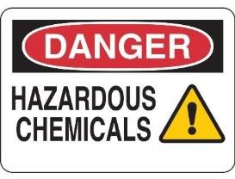
Note: The images displayed are in accordance with the requirements of the relevant statutory and regulatory authorities and are subject to change.

Disclaimer
The content of the E-mitra is intended to serve as a sample and guide for better understanding the NABH Entry Level Standards. It is not prescribed by NABH as the exclusive or only way to meet the standards. Healthcare organizations are encouraged to adapt and modify the materials according to their own scope of services and operational needs. NABH is not liable for any misinterpretations or errors resulting from the unmodified use of this material, or for any non-compliance during assessments that may arise because of such actions.

