

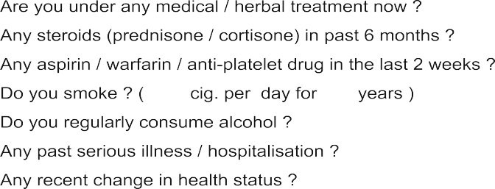
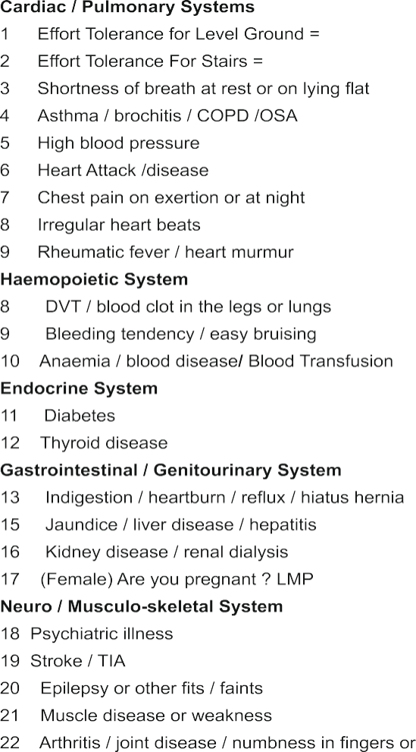
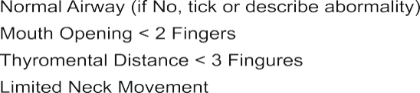
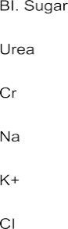
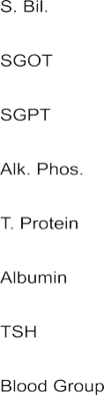
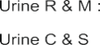

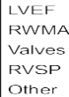
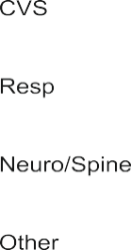
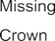
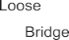


Document ID EM/FORMAT/24/V2.0 Document Version 02 Document Category Format Issue Date 06/2026

Pre-Anesthesia Assessment form
To be filled by doctor


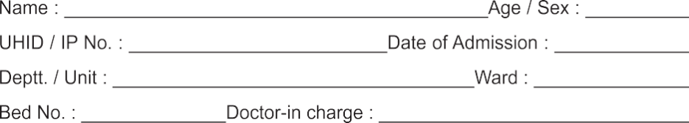

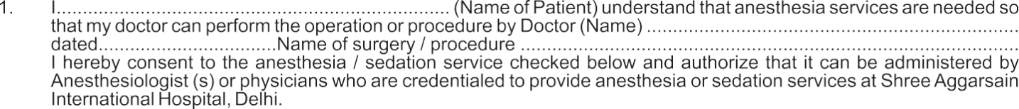

 |  | 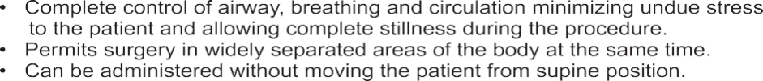
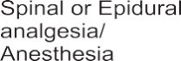

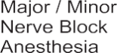 |  | 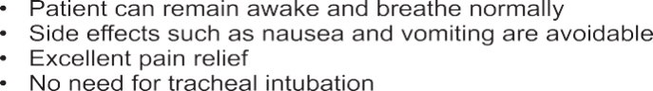
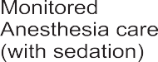
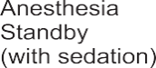
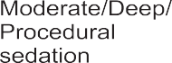
 |  | 

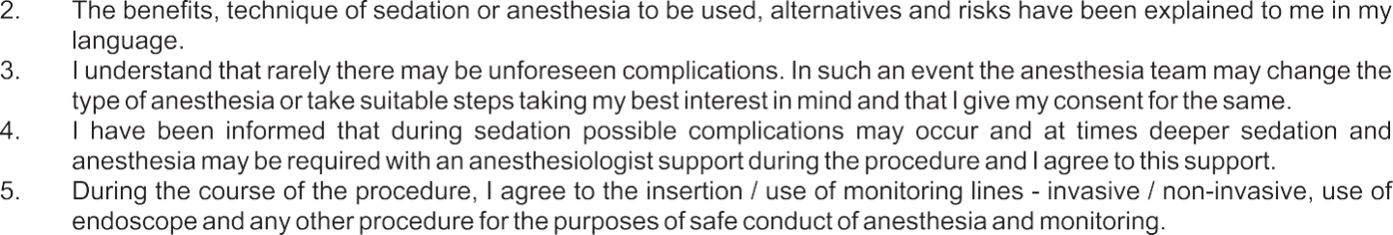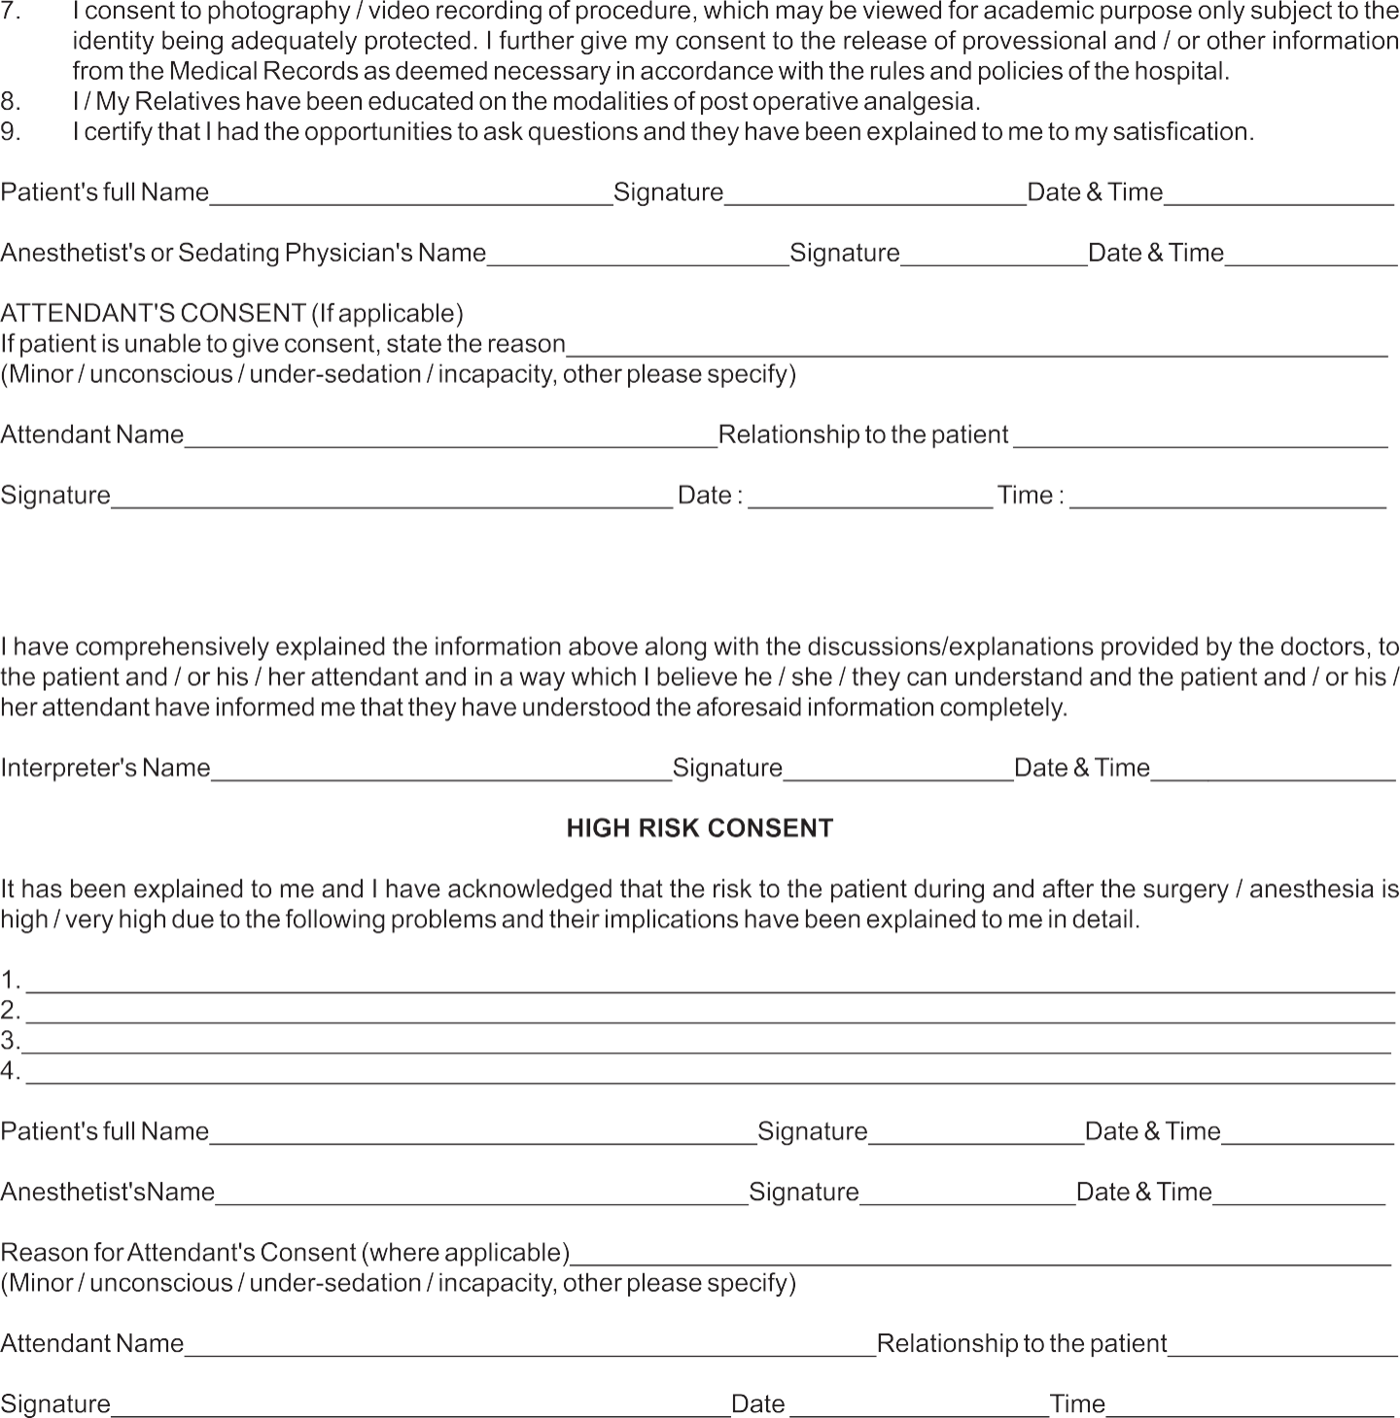

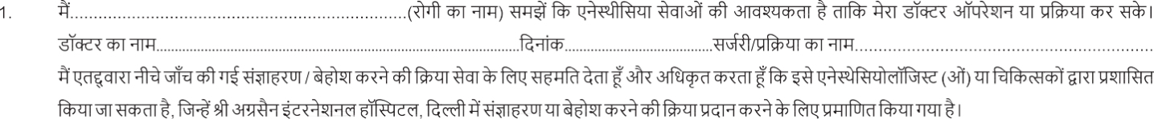
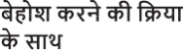

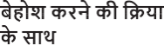

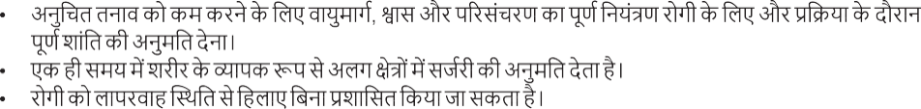
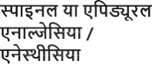
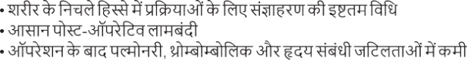

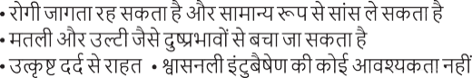
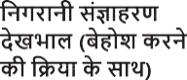
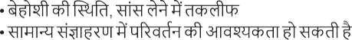
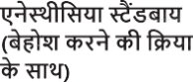

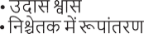

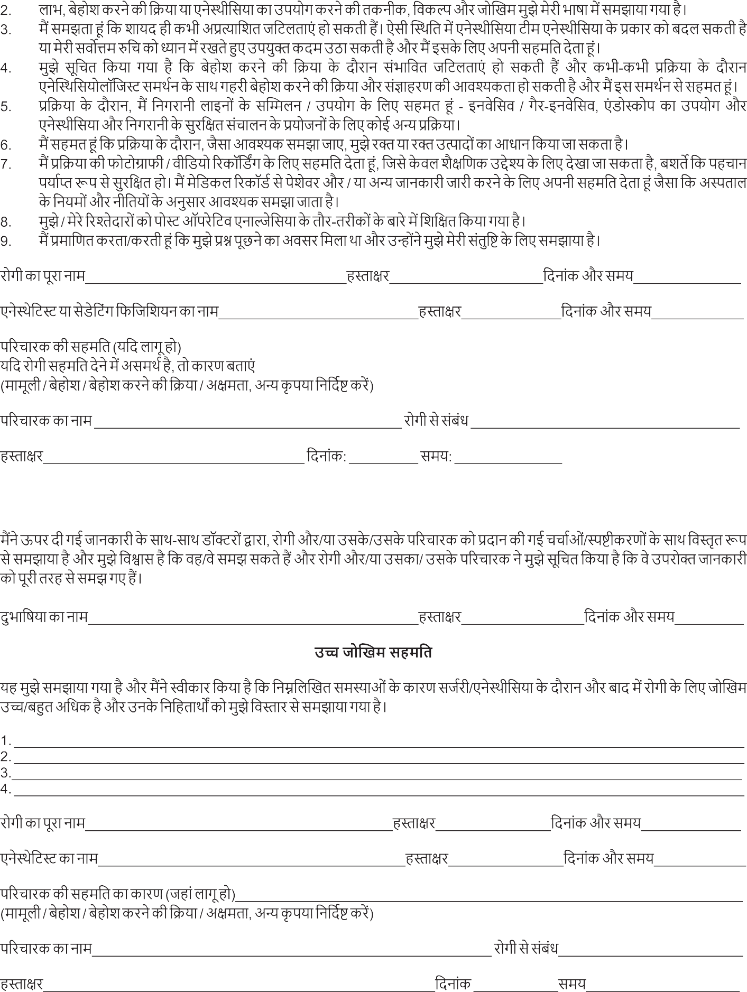
5


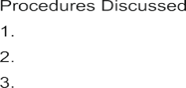


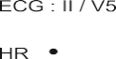
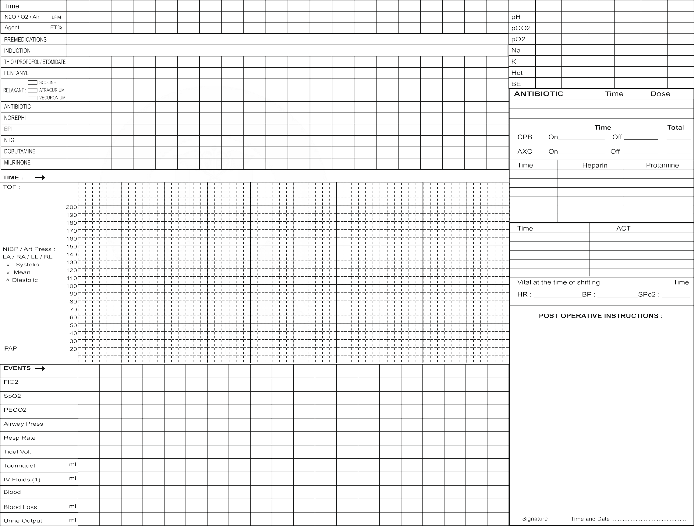

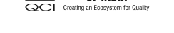
□ाT□KयT₹˛-प्रदTUT प्रRाTयन बोड₹˛
National Accreditation
Healthcare Providers

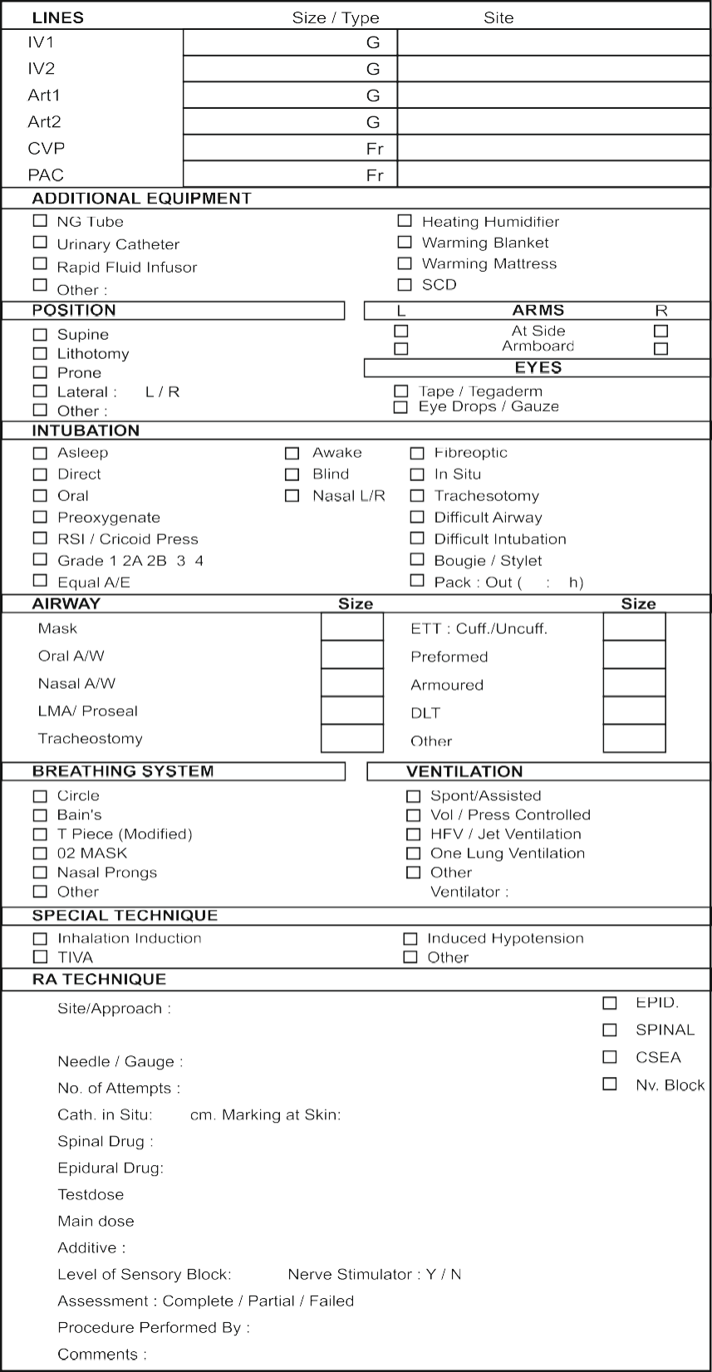

6



₹T□ा य अ□UTU औ₹
□ाT□KयT₹˛-प्रदTUT प्रRाTयन बोड₹˛
National Accreditation Board For Hospitals and Healthcare Providers

₹T□ा य अ□UTU औ₹
□ाT□KयT₹˛-प्रदTUT प्रRाTयन बोड₹˛
National Accreditation Board For Hospitals and Healthcare Providers

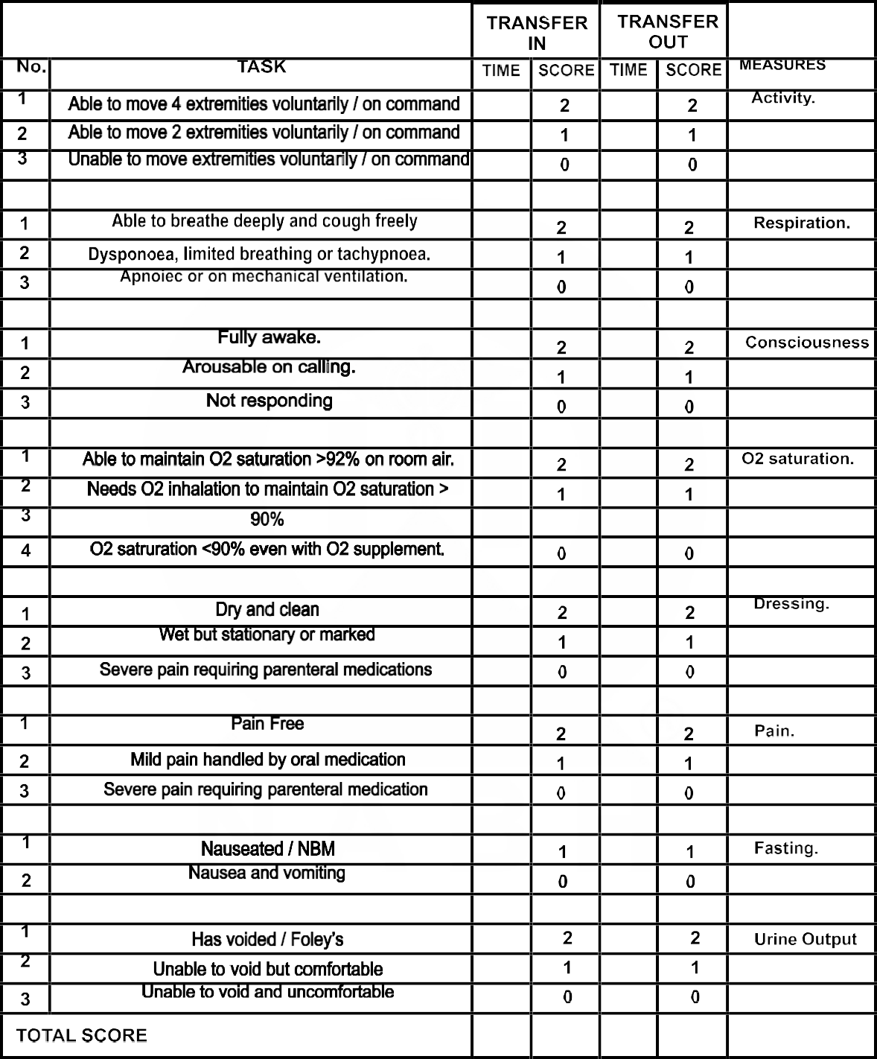

₹T□ा य अ□UTU औ₹
□ाT□KयT₹˛-प्रदTUT प्रRाTयन बोड₹˛
National Accreditation Board For Hospitals and Healthcare Providers

₹T□ा य अ□UTU औ₹
□ाT□KयT₹˛-प्रदTUT प्रRाTयन बोड₹˛
National Accreditation Board For Hospitals and Healthcare Providers

Disclaimer
The content of the E-mitra is intended to serve as a sample and guide for better understanding the NABH Entry Level Standards. It is not prescribed by NABH as the exclusive or only way to meet the standards. Healthcare organizations are encouraged to adapt and modify the materials according to their own scope of services and operational needs. NABH is not liable for any misinterpretations or errors resulting from the unmodified use of this material, or for any non-compliance during assessments that may arise because of such actions.



