Document ID EM/FORMAT/22/V2.0 Document Version 02 Document Category Format Issue Date 06/2026

Ante - Natal Services

ANC PNC Card
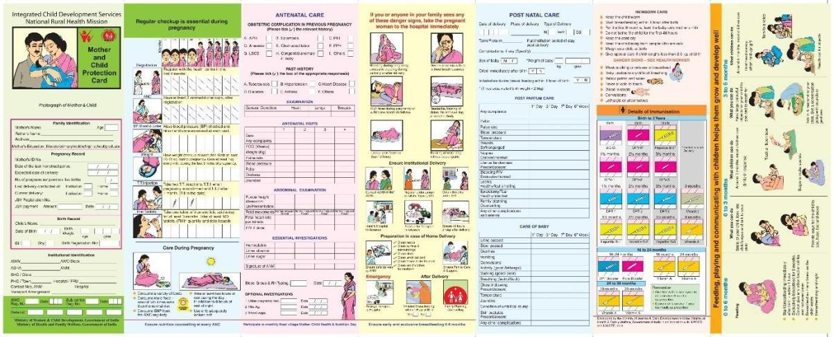

Nutrition Assessment for Pregnant Patients
Patient Name: Age: … Reg. No.:……………………………………. Date of Visit: Ht. ……………. Wt. BMI:
Diagnosis:

Nutrition Screening

Pre pregnancy weight (kg)
Pre-Pregnancy BMI (kg/m2)
Pregnancy trimester
Current weight (kg)
Weight gain with respect to trimester | Kgs | weeks of gestation
Trimester weight gain score | 0 | 4
Trimester weight gain score | For normal weight gain | For less weight gain
Biomedical parameter (Fe/Ca) | 0 | 2
Biomedical parameter (Fe/Ca) | If normal | If less
Any other complication (HTN/GDM) | 0 | 2
Any other complication (HTN/GDM) | No complication | For complication
Total Score

 | Score (0-  2) | Low Risk | No action is required, but nutritional reassessment should be continued  once in ten days

 | Score (2-6 | Medium Risk | Patients are encouraged to eat balanced- diet, nutritional  reassessment should be continued.
 | Score >6 | High Risk | Nutritional care plan should be initiated (calorie charting/Enteral  nutrition form)

Patient / Patient attendant food preferences & allergies (if any):…………………………………
Nutrition Care Plan:
…………………………………………………………………………………………………
….
Diet Recommended:…………………………………………………………………………………
…………………
Dietician Name: Time: Date:
Re-assessment due on:……………………………………

Nutrition Care Plan (High Risk Patients)
Kcal Goal: Protein Goal:………………………………………………………….
Any other nutrient goal:………………………………………………………………………………………….
Daily Round Follow Up for patient who are on calorie charting (Enteral nutrition chart separate)

Date
Energy Intake (kcal)
Protein Intake (gm)

Reference only (Weight gain score)

Weight status before pregnancy | Desired weight gain (kgs) | 1st trimester weight gain (kgs) | 2nd and 3rd trimester (kgs)
Underweight (<19.8  BMI) | 13-18 | 2.3 | 0.47
Average (19.8-26 BMI) | 11-16 | 1.6 | 0.44
Overweight (26-29 BMI) | 7-11 | 0.9 | 0.3
Obese (BMI=29) | 6-7

Twin gestation | 16-20
Triplet gestation | 20-25

Reference only Cut Off Point for the diagnosis of Anemia

 | Hb (g/dl) | Calcium (mg)
Adult, Females, Non-Pregnant | 12 | 8.5-10.1
Adult, Females, Pregnant | 11 | 8.5-10

Reference kcal and Protein Goal

 | Energy (kcal) | Protein (gm) | Calcium (mg) | Iron (mg)
Pregnancy | +350 | +18 g | 1200 | 35
Lactation 0-6  month | +600 | +14 g | 1200 | 21
6-12 month | +520 | +8 g | 1200 | 21

MATERNITY PROGRESS PROFILE
Dr. in charge:

Patient's Name:

Age: Registration
No.: Husband Name: Address:

Tel No.
Menstrual
History:
LMP: EDD:
Cycles:
Obstetric
History: Gravida: Parity:

FULL TERM | PRE-TERM | ABORTIONS | LIVE ISSUES

History of previous deliveries:

Mode Of Delivery | Indications  for LSCS (if any) | Sex | Baby Weight | Present Age | Place of Delivery | Complications

History of previous abortions:

Trimester | Induced/Spontaneou s | Year of Abortion | D&C. don

Past surgical history including Blood Transfusion:
Past Medical History:
1) DM 4) Allergies 7) Thyroid Disorder
2) HT 5) Asthma
3) TB 6) Any Other
Family History
1) DM 3) Twins 5) Genetic Defects
2) HT 4) Thalassemia 6) Any Other
Significant Risk Factor/s in this Pregnancy:

Breast: CVS: RS: Others: Inj. TT: 1st Dose 2nd dose

Visit No. | Date | W  t. | Pulse | BP | Temp | Edema | Pallor | POG (D) | POG (US  G) | Funchal Height | FHS | Presentation | FM | Hb | Urine R/M | P/V

Antenatal Investigations:

Test | Result | Date
CBC (Thal Screen)
Blood Group (Patient)
Blood Group (Husband)
Urine C/S
VDRL
Rubella (leggy)
Blood Sugar (1 hr. after 50 gm)
Glucose
HIV
Bhag
MSAFP Triple Panel
TSH
Blood Urea
Serum Creatinine
Serum Uric Acid
Platelet Count

ANTENATAL ULTRASOUND:

Date | Findings

NST:

Date | Findings

SPECIAL INVESTIGATION:

Date | Findings

Disclaimer
The content of the E-mitra is intended to serve as a sample and guide for better understanding the NABH Entry Level Standards. It is not prescribed by NABH as the exclusive or only way to meet the standards. Healthcare organizations are encouraged to adapt and modify the materials according to their own scope of services and operational needs. NABH is not liable for any misinterpretations or errors resulting from the unmodified use of this material, or for any non-compliance during assessments that may arise because of such actions.

