Document ID EM/FORMAT/30/V2.0 Document Version 02 Document Category Format Issue Date 06/2026

Initial Assessment Form Of Paediatrics Patient
Patients’ Name:
Age/Sex:
UHID:
Height:
Weight:
Time of Arrival:
Date:
Time of Assessment by Dr:

Medico-Legal Status: ☐ non-MLC ☐MLC No. ……………….
Presenting Complaints:

Vitals:
RR /Min
HR… /min
Temp °F
BP… mmHg
Spo₂ % GCS………………………
E………………. M……………… V……………….
Pupils…………………………. RBS mg/dL

History of Presenting Complaints:

Present Medical History:

Past Medical History:

History of Allergy: Family History:

Nutritional History:

Development History:
Pain Score:
No Pain/Mild Pain/ Moderate Pain/ Severe Pain

Vaccination History:

Socio – Economic History

General Examination: PALLOR / ICTERUS / CLUBBING / LYMPHADENOPATHY / OEDEMA

Weight: Height: BMI: Head Circumference:
Other Signs:

Nutritional Assessment:

Identification of special needs:

Systemic Examination Respiratory System:

Cardiovascular System:

Per Abdomen:
Blood Investigations:
- CBC
- CRP
- KFT
- LFT
- PT INR
- Blood C/S
- Urine R/E
- Urine C/S
- Malaria Antigen
- Typhi Dot IgM

Other Investigations:
……………………………………
……………………………………
……………………………………
……………………………………
Radiology Investigation:
- X-Ray
- CT scan
- MRI

Nervous System:

Other:

Provisional Diagnosis:

Treatment Plan:

Dietary Plan:

Safe Parenting Instructions:

Referral Doctor

Admission: ☐ PICU ☐ Ward ☐ Day Care
Condition: ☐ Stable ☐ Serious ☐ Critical ☐ End of Life

Admission under Consultant 1 Consultant 2
…………………………………
I have been explained the current condition, management, alternatives and prognosis. All my questions have been answered satisfactorily. I have understood the above instructions and I agree with the plan.

Patient Attendant Name/ Sign. Doctor Name/ Sign.

CLINICAL PROGRESS NOTES

DATE & TIME | NOTES

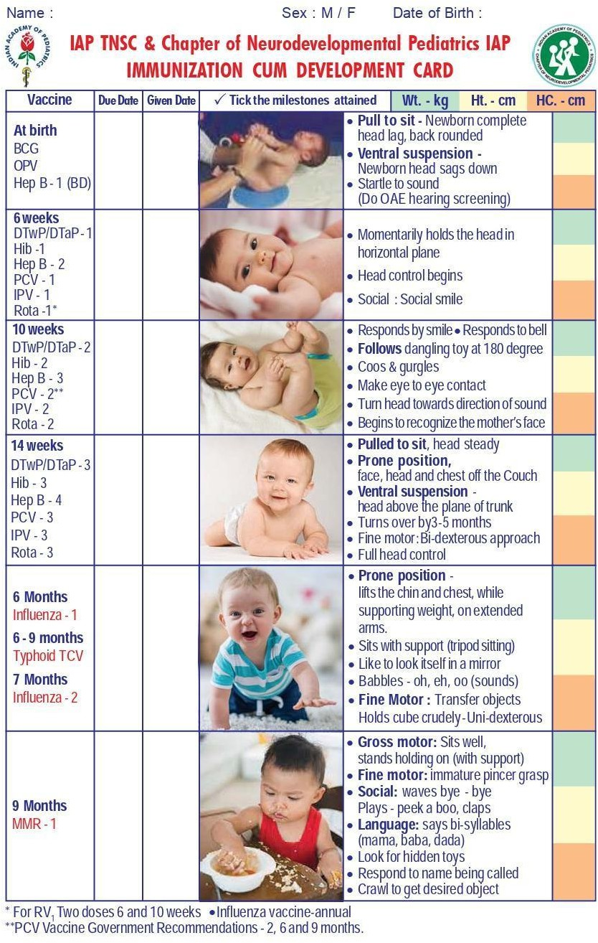

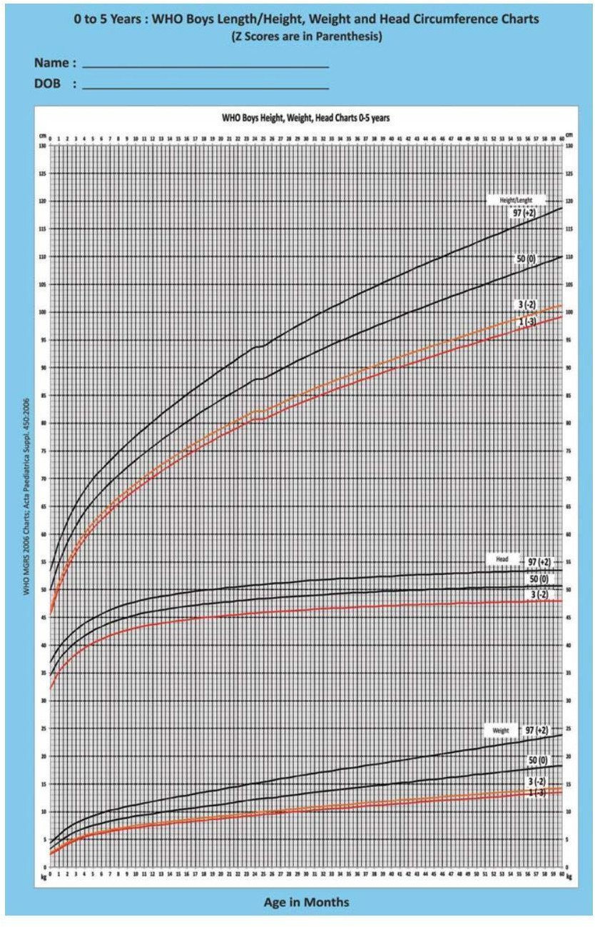

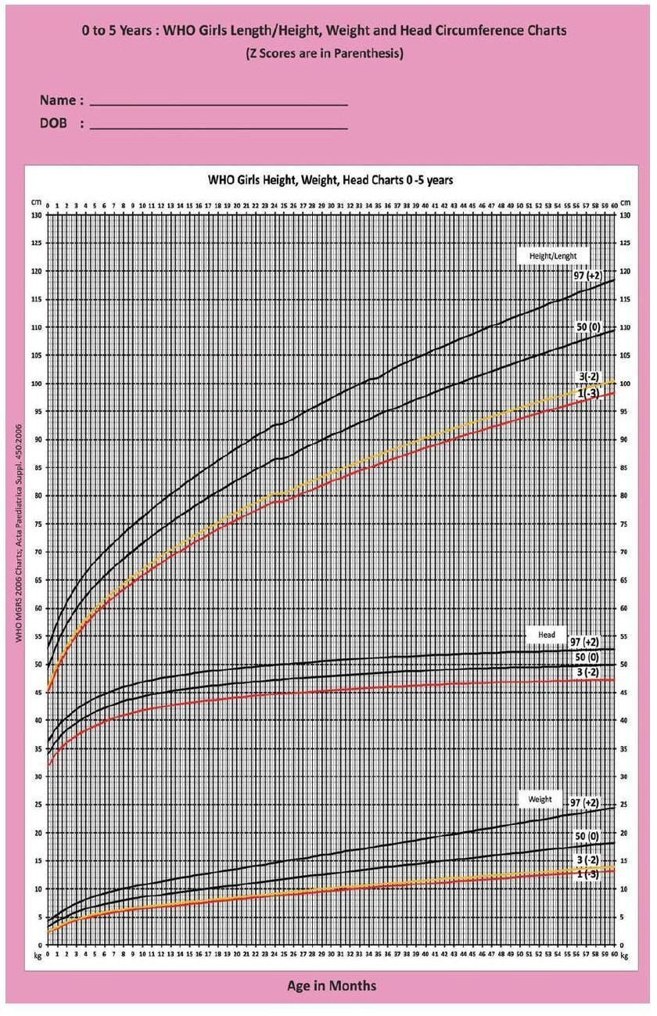

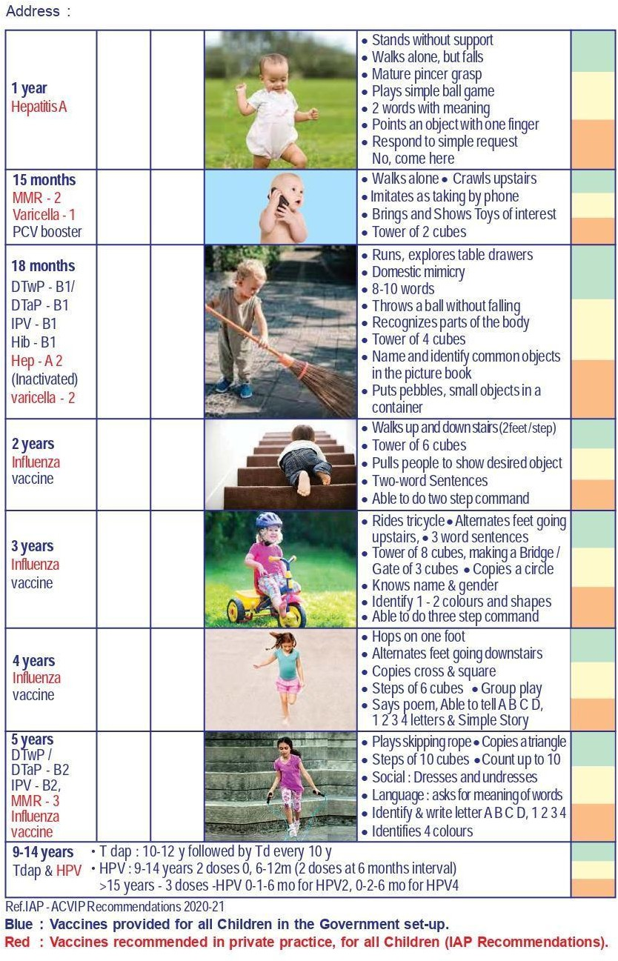

Disclaimer
The content of the E-mitra is intended to serve as a sample and guide for better understanding the NABH Entry Level Standards. It is not prescribed by NABH as the exclusive or only way to meet the standards. Healthcare organizations are encouraged to adapt and modify the materials according to their own scope of services and operational needs. NABH is not liable for any misinterpretations or errors resulting from the unmodified use of this material, or for any non-compliance during assessments that may arise because of such actions.

