Document ID EM/FORMAT/36/V2.0 Document Version 02 Document Category Format Issue Date 06/2026

Initial Assessment For Physio - Rehab. O.P.D. Patient

Patient’s Name |  | Age/Gender
Occupation |  | UHID No.
Diagnosis |  | Treating Physiotherapist
Date: |  | Reg. No. of Physio. Dept.
Contact No. of Patient |  | Reg. No. of Physio. Dept.
Ref. Doctor

Chief Complaints

History of present illness

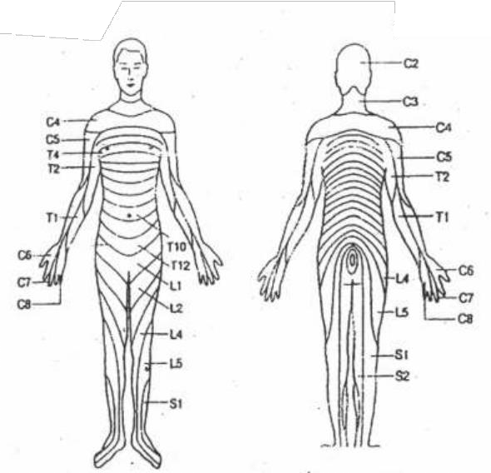
History of Pain
- Location of Pain
- Onset of Pain
- Character of Pain
- Aggravating / Relieving Positions
- Intensity

0 ( No Pain) 5 (Moderate Pain) 10 ( Worse Pain)

Diabetes Mellitus | Hypertension | Tuberculosis | Surgery ( if any)

Observation
- Obvious swelling ☐ Yes ☐ No
- Deformity / Contracture ☐ Yes ☐ No
- Gait and Posture

- Others :

Palpation
- Temperature of Skin ☐ Warm ☐ Cold
- Tenderness ☐ Yes ☐ No
- Muscle Spasm ☐ Yes ☐ No

On Examination Joint R.O.M. Active
Passive
Muscle Tightness ☐ Present ☐ Absent Muscle Wasting ☐ Present ☐ Absent

Neurological Involvement

Sensory Examination :
- Kinesthetic Sensation

- Reflexes

Investigation

Clinical Diagnosis

Treatment

Prognosis

Name & Signature of Physiotherapist

Date Time

FUNCTIONAL ASSESSMENT OF PATIENTS FOR PHYSIO / REHAB.

Patient’s Name Age/Sex Regn. No. IP/Physio No.

ACTIVITIES / PARTICIPATIONS |  |  | Independent | Assisted | Impossible
MOBILITY
 | Crawling
 | Crouching Gait
 | Walking
 | Squatting
 | Stairs
 | Running
TRANSFERS
 | Lie to Sit (& opposite)
 | Sit to Stand (& opposite)
 | Stand to Floor (& opposite)
 | Sit to sit
BALANCE
 | Sitting
 | Standing
 | On one leg
UPPER LIMB FUNCTIONS
 | Grasp | R

 |  | L
 | Release | R
 |  | L
 | Fine Manipulation | R
 |  | L
 | Holding | R
 |  | L
DAILY LIFE ACTIVITIES
 | Dressing – Upper body
 | Dressing – Lower body
 | Toileting
 | Bathing
 | Washing oneself
 | Eating
 | Drinking
ASSISTED DEVICES
 | Without assisted devices
 | One crutch |  |  | Good | Bad
 | Pair of crutches |  |  | Good | Bad
 | Walking Frame |  |  | Good | Bad
 | Wheel Chair |  |  | Good | Bad

 | Orthosis right side |  | Good | Bad | FO | AFO | SHOE RAISE
 | Orthosis left side |  | Good | Bad | FO | AFO | SHOE RAISE

Range of Motion/ Manual Muscle Testing
UPPER LIMB |  |  | ROM |  | MMT
 |  |  | L | R | L | R
SHOULDER
 | Flexion | 180
 | Extension | 60
 | Abduction | 180
 | Adduction | 30
 | Medial  Rotation | 95
 | Lateral  Rotation | 80
ELBOW
 | Flexion | 150
 | Extension | 0
FOREARM
 | Pronation | 80
 | Supination | 80
WRIST
 | Flexion | 80
 | Extension | 80
 | Abduction | 20
 | Adduction | 35
FINGERS
 | Thumb opposition
 | MP Flexion | 90
 | MP  Extension | 40
 | IP Flexion | 120

LOWER LIMB |  |  | ROM |  | MMT
 |  |  | L | R | L | R
HIP
 | Flexion | 120
 | Extension | 30
 | Abduction | 45
 | Adduction | 30
 | Medial Rotation | 30
 | Lateral Rotation | 60
KNEE
 | Flexion | 135
 | Extension | 0
ANKLE-FOOT
 | Dorsiflexion | 30
 | Plantar Flexion | 45
 | Inversion | 35
 | Eversion | 15

Name & Signature of Physiotherapist

Date Time

Disclaimer
The content of the E-mitra is intended to serve as a sample and guide for better understanding the NABH Entry Level Standards. It is not prescribed by NABH as the exclusive or only way to meet the standards. Healthcare organizations are encouraged to adapt and modify the materials according to their own scope of services and operational needs. NABH is not liable for any misinterpretations or errors resulting from the unmodified use of this material, or for any non-compliance during assessments that may arise because of such actions.

