Document ID EM/FORMAT/09/V2.0 Document Version 02 Document Category Format Issue Date 06/2026

Patient Feedback Form

OPD FEEDBACK FORM
We thank you for choosing Hospital Name as your healthcare partner. In order to improve our services we request you to spare some time and give your valuable feedback.
- Please rate courteous behaviour & promptness of the Billing/reception counter staff.
Excellent Good Fair Poor Unacceptable

- How long did you wait to see the doctor after Billing was done?
Excellent <10 Min Good <20 Min Fair<30 min Poor >30 min Unacceptable min

- Please rate your experience with doctors.
Excellent Good Fair Poor Unacceptable

- Please rate your experience with Nursing Staff.
Excellent Good Fair Poor Unacceptable

- Please rate your experience with pathology/laboratory/blood investigation services.
Excellent Good Fair Poor Unacceptable
- Please rate your experience with Hospital Pharmacy Services.
Excellent Good Fair Poor Unacceptable

- Please rate your experience with Hospital Ambiance, washroom cleanliness and waiting area.

Excellent Good Fair Poor Unacceptable

- Will you prefer to visit again in future for your health care needs? ☐ Yes ☐No
- Will you refer others to visit Hospital Name? ☐Yes ☐No

- Please write suggestions or remarks for any of the above service if rated as Poor/Unacceptable:

Can we share your feedback on social media platform ☐Yes ☐No

Your Name: | Date: | Time:
Doctor’s Name: | Mobile Number: | Bill Number:


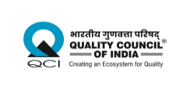
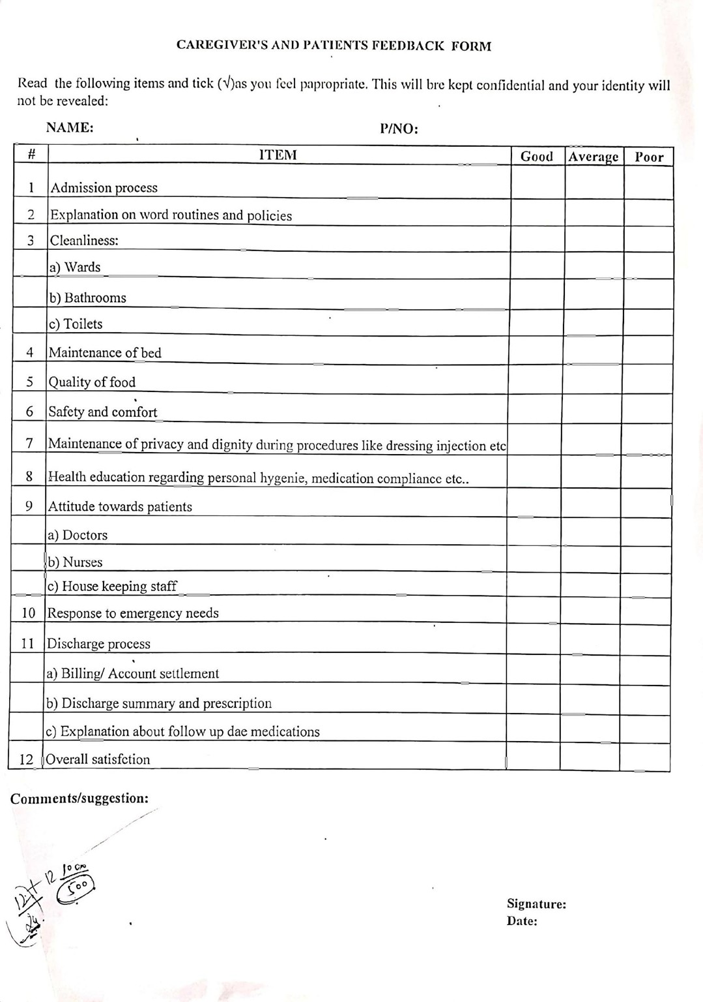

Djdddd

Disclaimer
The content of the E-mitra is intended to serve as a sample and guide for better understanding the NABH Entry Level Standards. It is not prescribed by NABH as the exclusive or only way to meet the standards. Healthcare organizations are encouraged to adapt and modify the materials according to their own scope of services and operational needs. NABH is not liable for any misinterpretations or errors resulting from the unmodified use of this material, or for any non-compliance during assessments that may arise because of such actions.

