Document ID EM/FORMAT/64/V2.0 Document Version 02 Document Category Format Issue Date 06/2026

CSSD Register

IDEAL LAYOUT OF CSSD

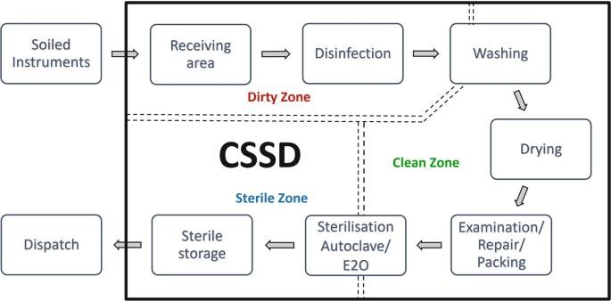

BOWIE-DICK TEST

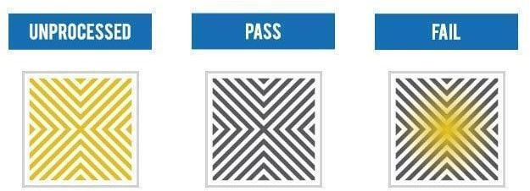

CHEMICAL INDICATORS
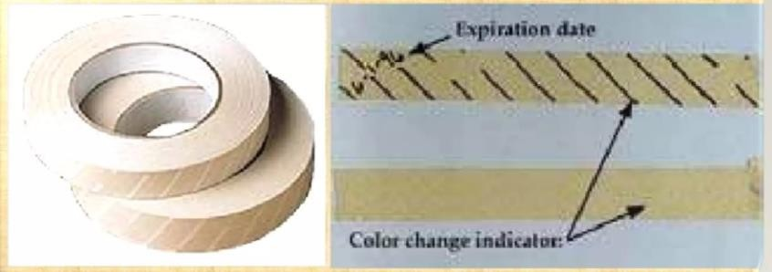

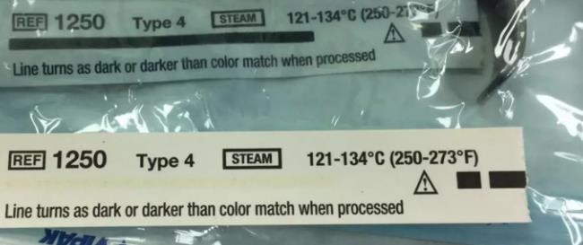

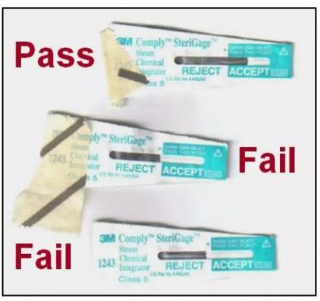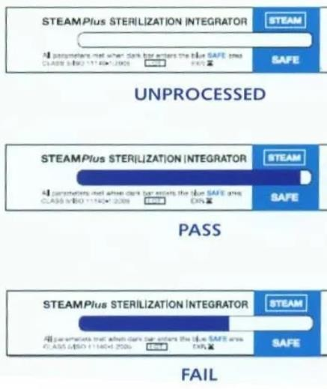
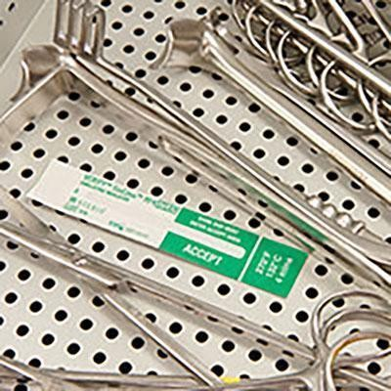
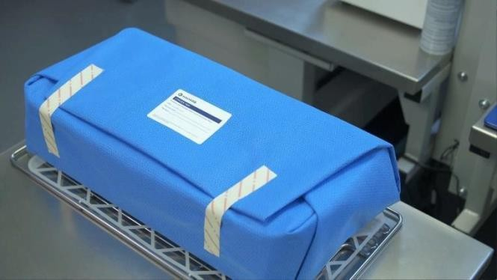

BIOLOGICAL INDICATORS
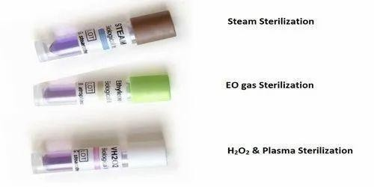

CSSD ETO LOAD REGISTER

S.no | Date | Time | Name of dept. | Name of Set/Item | Quantity | Load no. | Sterilization time | Temp | Cycle | PCD | Chemical indicator | ETO  label | Biological indicator | Name of CSSD  staff | Sign of CSSD  staff

CSSD AUTOCLAVE LOAD REGISTER

S no. | Date | Name of set  / item | Quantity | Load no. | Process time | Heating time | Pressure | Temp | Sterili-zation time | Dry time | PCD | Chemi-cal indicator | Autoclave label | Biological indicator | Bowie  -  Dick/ Leak test | Name of CSSD  Staff | Sign of CSSD  Staff

CSSD BIOLOGICAL INDICATOR REGISTER

DATE | AUTOCLAV E  CULTURE | QUANTITY | NAME OF STAFF SEND BY | SIGNATURE OF STAFF SEND BY | NAME OF STAFF RECEIVED BY | SIGNATURE OF STAFF RECEIVED BY

Disclaimer
The content of the E-mitra is intended to serve as a sample and guide for better understanding the NABH Entry Level Standards. It is not prescribed by NABH as the exclusive or only way to meet the standards. Healthcare organizations are encouraged to adapt and modify the materials according to their own scope of services and operational needs. NABH is not liable for any misinterpretations or errors resulting from the unmodified use of this material, or for any non-compliance during assessments that may arise because of such actions.

